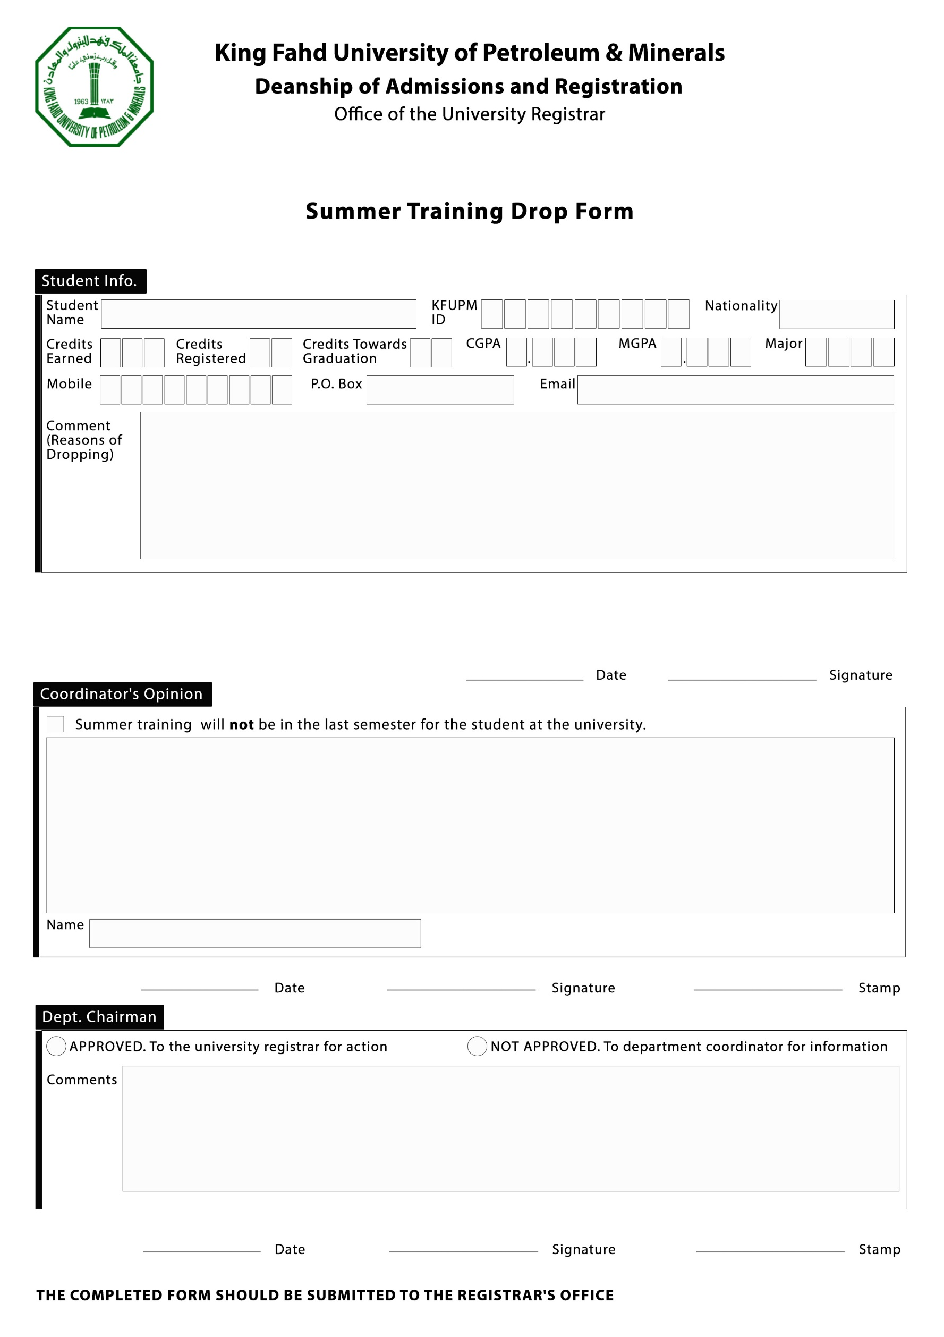

***Please tick a box only when applicable:***

*I have no training opportunity at the time of dropping.*

*I have a training opportunity, but I will notify the company about my status.*

*Summer training will not be taken in my last semester.*

0

5