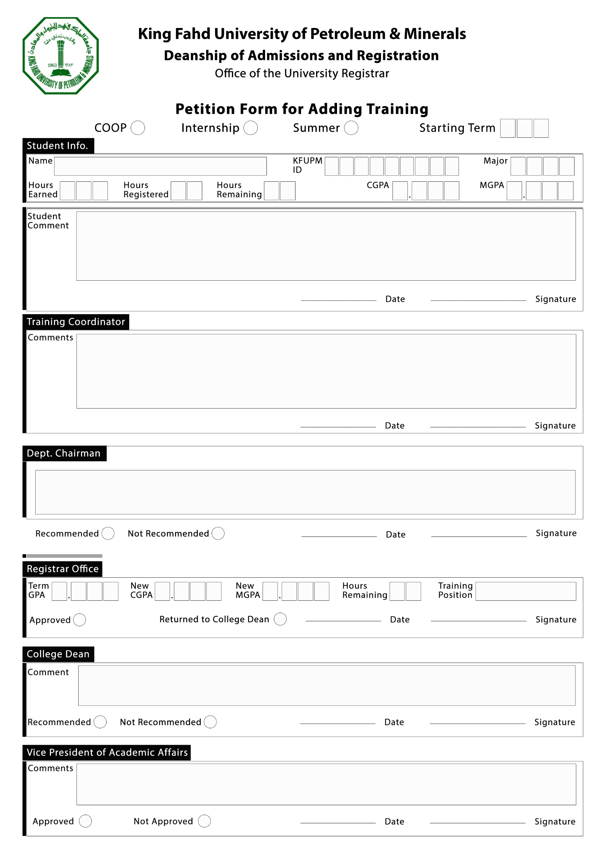s

**20**

**NOTES: If the case is GPA-related, the Registrar and Dean's sections is to be filled out only at the end of the semester. By default, the registrar keeps the form, but the academic department may choose to keep it and forward it at the end of the term. Other petition cases go directly to the dean.**

***Note: Students with a CGPA or MGPA lower than 2.0 should also fill out the declaration form, to be attached to this petition, along with degree plan for all remaining courses (including courses registered this semester*** ***and COOP or Summer Training) and show expected grade in each course and the expected*** ***CGPA & MGPA after the end of each semester.***